**Lesson 2 – Levels B1 – C1**

1. Introduce yourself to your group. Tell them a little about yourself, your family, what you do…

2. Write about your classmates.

3. Simple Present / Question words – Take notes about what your teacher is going to explain.

4. Guess who – Choose someone famous and think about his/her appearance, profession, routine… Tell your friends about it so they can guess who you’re talking about.

5. Answer the questions according to what you hear.

a. What does Todd do?

R: Todd is a teacher

b. What time does he get up?

R: He get up at 6:00 am.

c. When does he get home?

R: He don’t get home until the night usually.

d. Where does he go to have fun?

R: He like to Hiking and go to the mountains.

e. Who does he live with?

R: He lives alone.

f. What does he do on Sunday?

R: He climb his house.

g. Why do people get mad at him on the road?

R: Because he drives slowly.

h. How often does Todd see his family.

R: He see them once a year.

i. How is winter like where his family lives?

R: it’s too cold.

6. Write a small paragraph about yourself based on the topics of the listening.

7. It’s time to have conversation. Talk to your classmates and compare your lives, what do you have in common? What is different?

8. Ask your partner questions so you can fill in your text. 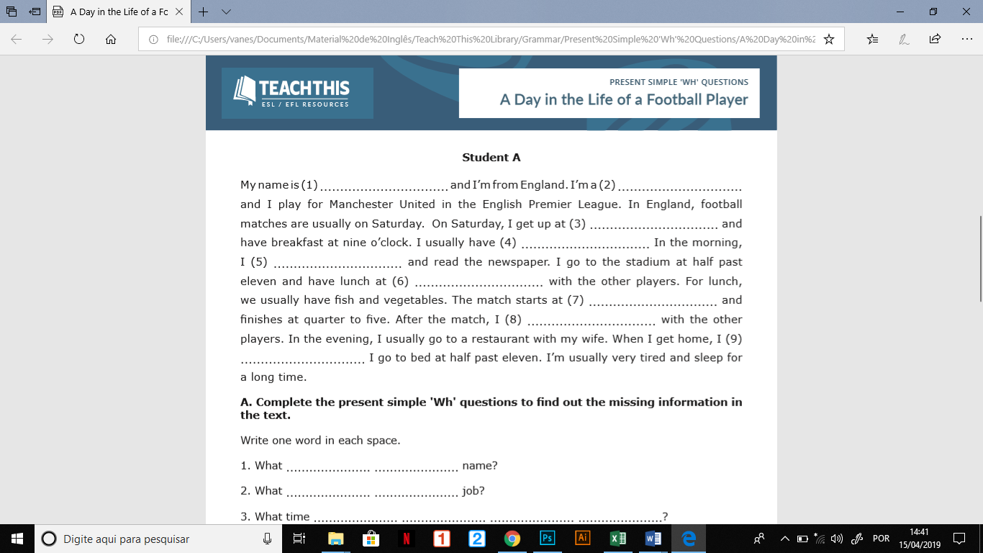

1.

2.

3.

4.

5.

6.

7.

8.

9.

10.

11.

12.

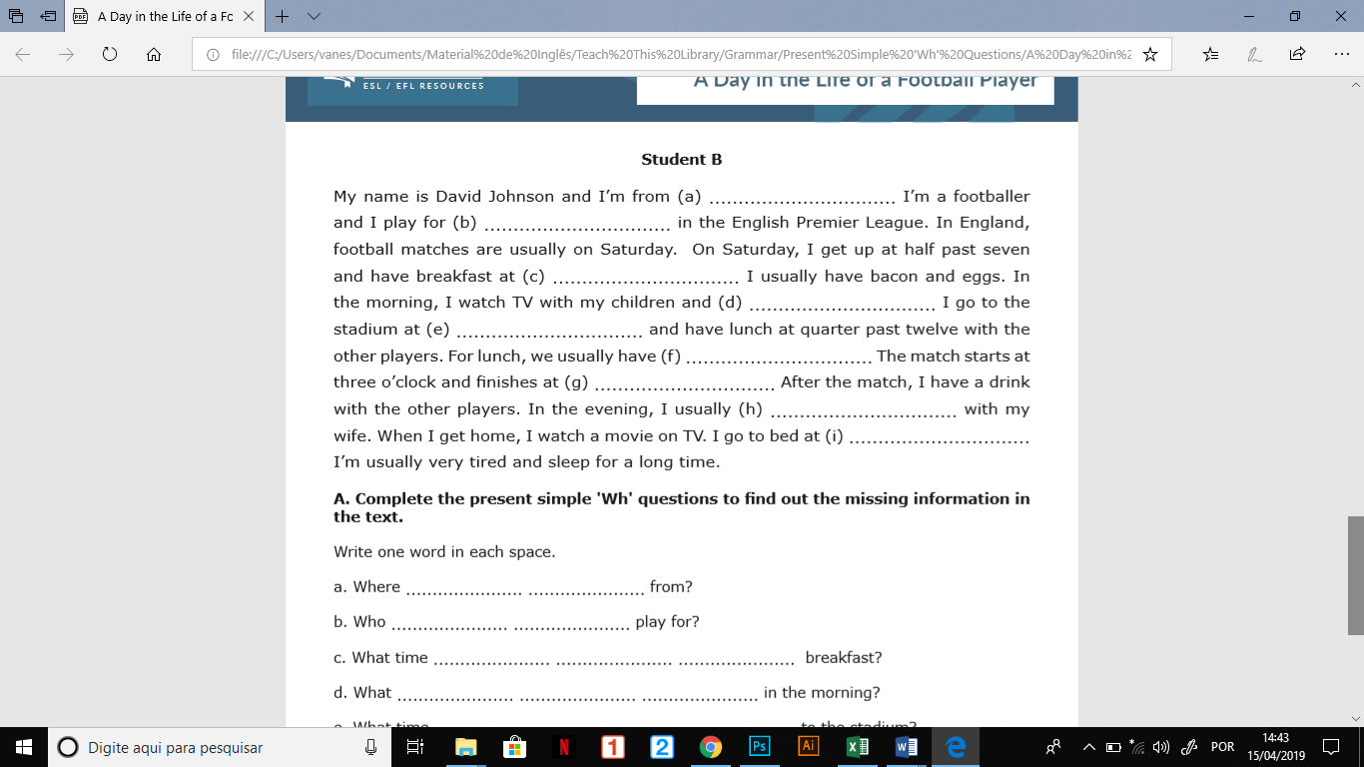

a. He is from England.

b. He plays for Manchester United.

C. David have hos breakfast at nine o’clock.

d. In the morning, he read the newspapers.

e. He goes to the stadium at half past eleven.

f. His lunch is basically Fish and vegetables

g. The match finishes at quarter to five.

h. He usually goes to a restaurant with his wife.

i. He goes to bed at half past eleven.

9. Quizlet live – 100 most common verbs.

10. Watch the video and write a paragraph about what the characters do every day.

 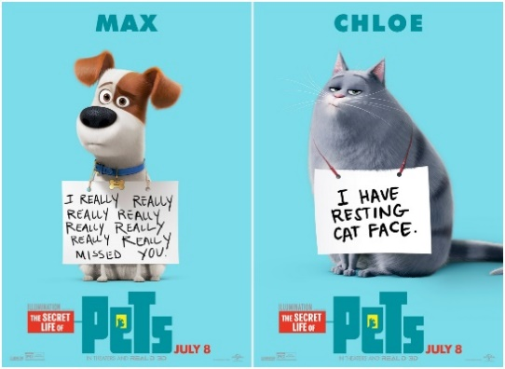 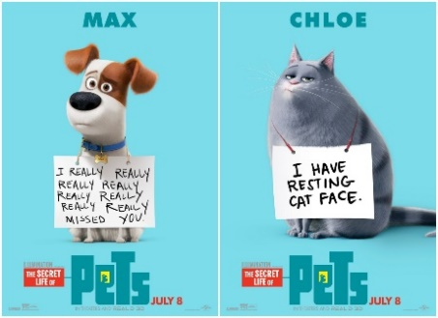   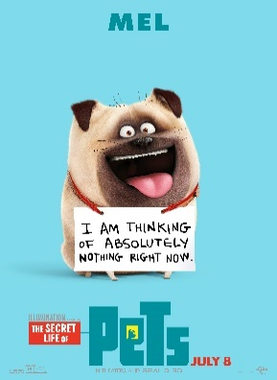

Buddy

Mel

Gidget

Sweetpea

Chloe

Max

 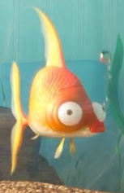 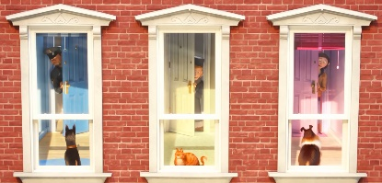 

Leonard and its friends

The pets’ owners

Tino

Leonard

11. Read the following text and discuss the questions with your classmates.

**Food Waste**

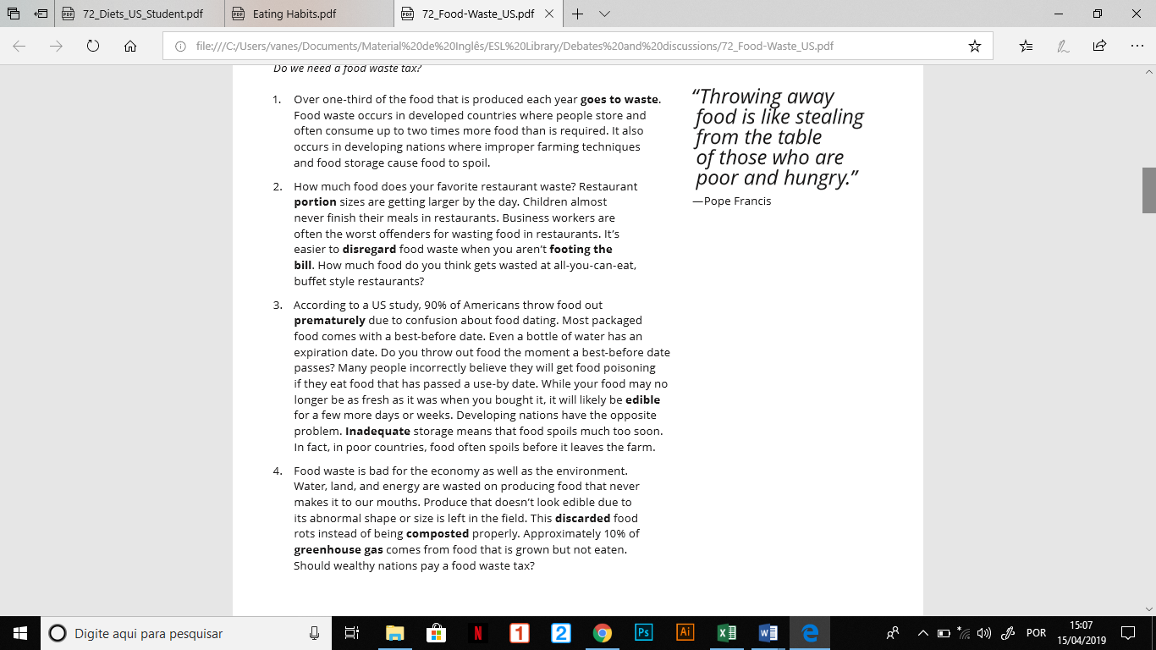

a. Where is food waste a problem?

b. Why is it an environmental concern?

c. What could we do to solve the food waste problem?